# Lab 5 part 1

In this part, students will develop a mobile application for using internal storage. The layout included will be shown below:

Here are the screen captures of the application:

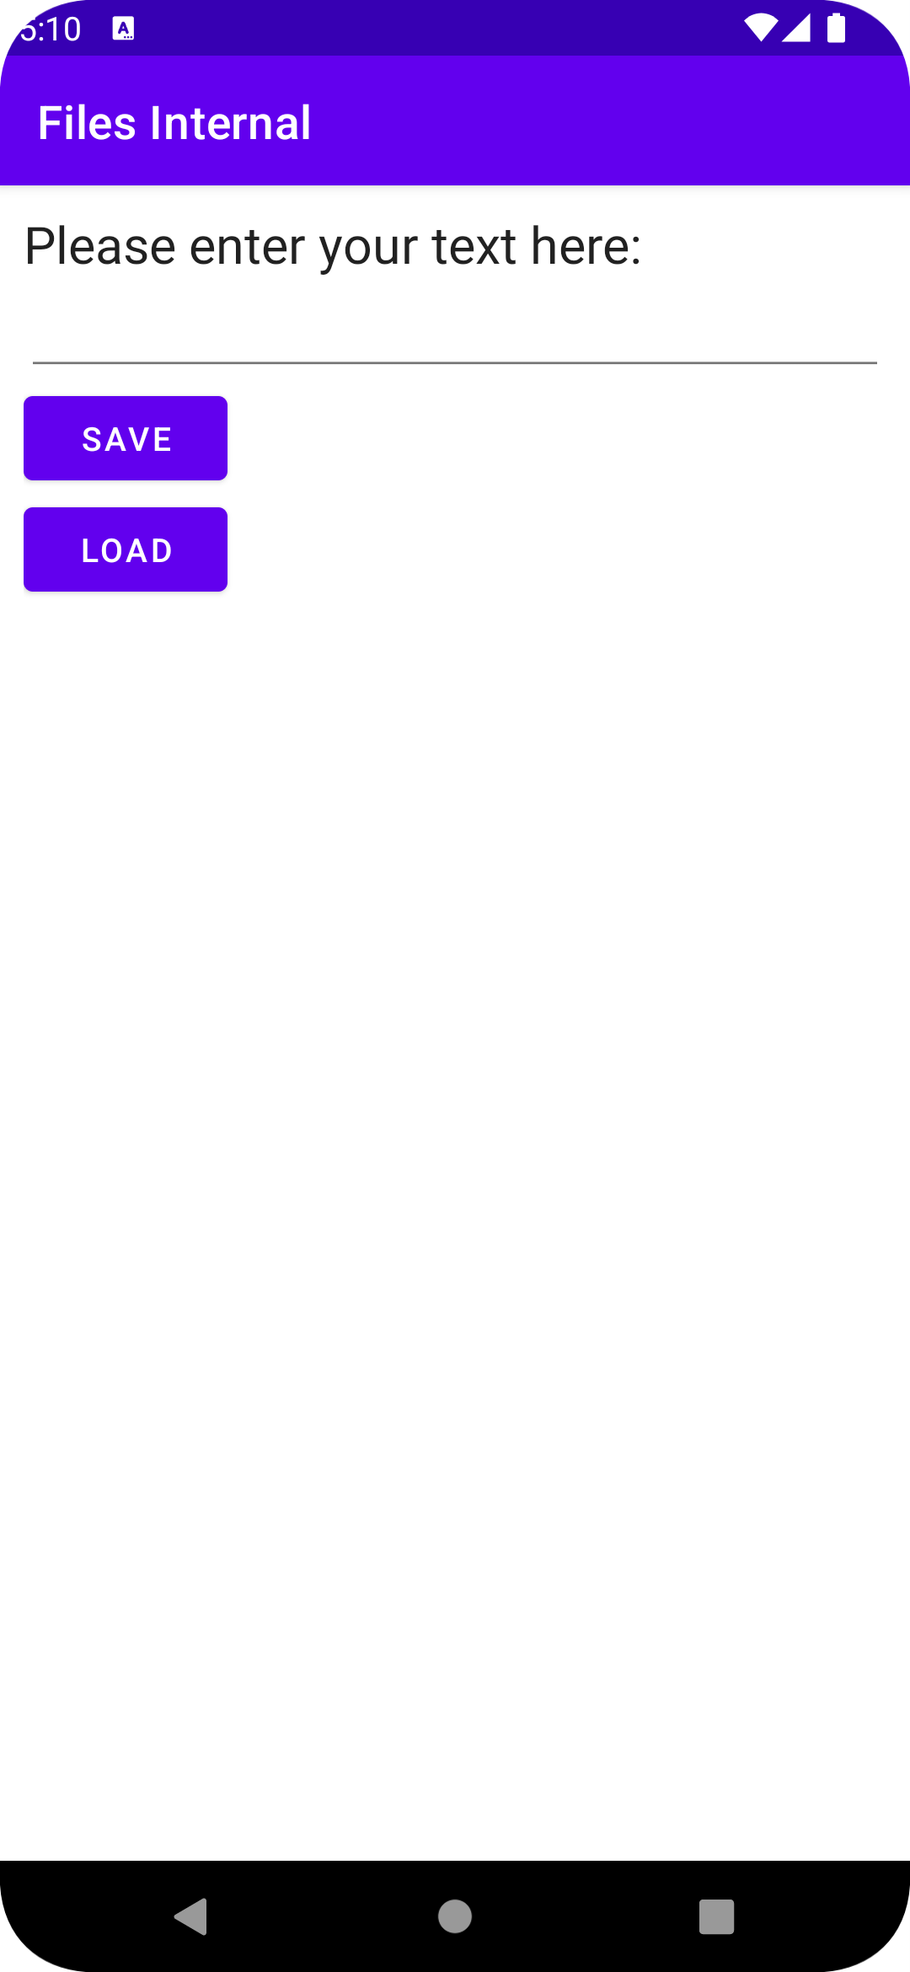

Step 1:

In Android Studio, create a new project named Lab 6 with following project setting:

* Choose your project : **Empty Activity**
* Application Name : **Lab 5 part 1**
* Project location : use the default setting
* Language : **Java**
* Minimum API level: **API 21: Android 5.0 (Lollipop)**
* Click **Finish**

Step 2:  
Open activity_main.xml and insert the following code:

*<?*xml version="1.0" encoding="utf-8"*?>*<LinearLayout xmlns:android="http://schemas.android.com/apk/res/android"  
 android:layout_width="fill_parent"  
 android:layout_height="fill_parent"  
 android:orientation="vertical"  
 android:padding="10dp" >  
 <TextView  
 android:layout_width="wrap_content"  
 android:layout_height="wrap_content"  
 android:text="Please enter your text here:"  
 android:textAppearance="?android:attr/textAppearanceLarge" />  
 <EditText  
 android:id="@+id/editText1"  
 android:layout_width="match_parent"  
 android:layout_height="wrap_content" />  
 <Button  
 android:id="@+id/save_button"  
 android:layout_width="wrap_content"  
 android:layout_height="wrap_content"  
 android:onClick="onClickSave"  
 android:text="Save" />

<Button  
 android:id="@+id/load_button"  
 android:layout_width="wrap_content"  
 android:layout_height="wrap_content"  
 android:onClick="onClickLoad"  
 android:text="Load" />  
</LinearLayout>

Step 3:

Open MainActivity.java and insert the following code to define the attributes we need:

public class MainActivity extends AppCompatActivity {  
 EditText mEditText;  
 static final int *READ_BLOCK_SIZE* = 100;  
 @Override  
 protected void onCreate(Bundle savedInstanceState) {  
 super.onCreate(savedInstanceState);  
 setContentView(R.layout.*activity_main*);  
 mEditText = findViewById(R.id.*editText1*);  
 }

}

Step 4:

Add onClickSave() and onClickLoad() method inside the MainActivity for the creation and loading of text file.

public void onClickSave(View view){

}

public void onClickLoad(View view){

}

Step 5:

In onClickSave(), FileOutputStream will be used to define the name of file that we need to create. OutputStreamWriter will be used to create the content of file. To fulfil the requirement of using these objects, we need to use try and catch for error detection.

public void onClickSave(View view) {  
 String str = mEditText.getText().toString();  
 try {  
 FileOutputStream fOut = openFileOutput("text.txt", *MODE_PRIVATE*);  
 OutputStreamWriter osw = new OutputStreamWriter(fOut);  
 osw.write(str);  
 osw.flush();  
 osw.close();  
  
 Toast.*makeText*(getApplicationContext(), "File save successfully", Toast.*LENGTH_SHORT*).show();  
 mEditText.setText("");  
  
 } catch (IOException ioe) {  
 ioe.printStackTrace();  
  
 }  
  
  
}

Step 6:

In onClickLoad(), FileInputStream will be used to define the name of file that we need to load. InputStreamReader will be used to load the content of file. To fulfil the requirement of using these objects, it is necessary to use try and catch for error detection.

public void onClickLoad(View view){  
 try{  
 FileInputStream fIn =openFileInput("text.txt");  
 InputStreamReader isr =new InputStreamReader(fIn);  
  
 char[] inputBuffer=new char[READ_BLOCK_SIZE];  
 String s = "";  
 int charRead;  
 while((charRead=isr.read(inputBuffer))>0){  
 String readString=String.*copyValueOf*(inputBuffer,0,charRead);  
 s+=readString;  
 inputBuffer=new char[READ_BLOCK_SIZE];  
 }  
  
 mEditText.setText(s);  
 Toast.*makeText*(getApplicationContext(), "File loaded successfully", Toast.*LENGTH_SHORT*).show();  
 }catch (IOException ioe){  
 ioe.printStackTrace();  
 }  
  
}